**Screen Shots for Swarm Microservice Deployment**

**Docker Services:**

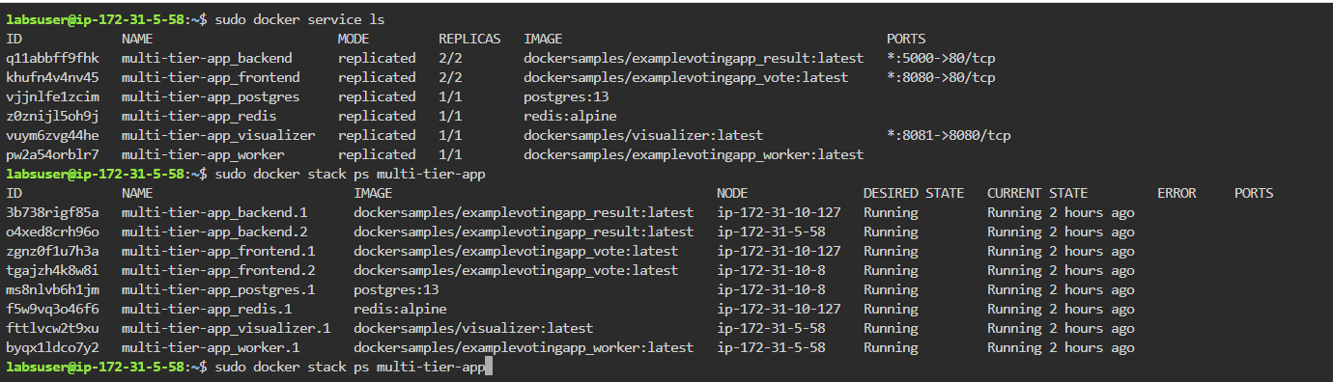

**Docker-compose File:**

